Mobile Money Switches
# Source: AI Source: Provided by: [Data Path: Persons Table -> ID Column: 1, Name_En Column: Motasem Essam] -> From: [ChatGPT] on [1/21/2026]
A Mobile Money Switch is a specialized clearing system that facilitates the exchange of mobile money transactions between different mobile money providers, banks, and financial institutions. It enables interoperability, allowing users on one platform (e.g., Vodafone Cash) to send or receive funds from another platform (e.g., Orange Money or a bank account).

🧠 Simple Definition
# Source: AI Source: Provided by: [Data Path: Persons Table -> ID Column: 1, Name_En Column: Motasem Essam] -> From: [ChatGPT] on [1/21/2026]
A Mobile Money Switch is a digital clearing house that connects multiple mobile money services and banks, enabling smooth, secure, and interoperable transactions across providers.

🔁 Where It Fits in the Payment Flow
# Source: AI Source: Provided by: [Data Path: Persons Table -> ID Column: 1, Name_En Column: Motasem Essam] -> From: [ChatGPT] on [1/21/2026]
- A user sends money from one wallet (Provider A) to another (Provider B).
- The Mobile Money Switch validates, routes, and matches the transaction between the two providers.
- It then sends net settlement instructions to the central bank or settlement entity for final fund movement.

🎯 Key Roles of Mobile Money Switches
# Source: AI Source: Provided by: [Data Path: Persons Table -> ID Column: 1, Name_En Column: Motasem Essam] -> From: [ChatGPT] on [1/21/2026]
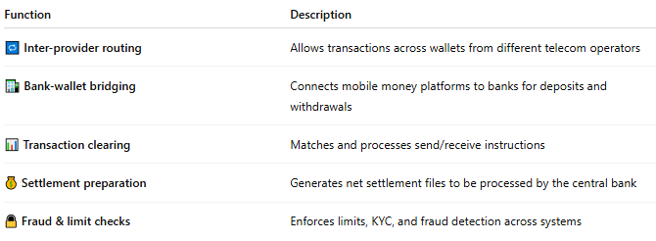

Function | Description
🔁 Inter-provider routing | Allows transactions across wallets from different telecom operators
🏦 Bank-wallet bridging | Connects mobile money platforms to banks for deposits and withdrawals
📊 Transaction clearing | Matches and processes send/receive instructions
💰 Settlement preparation | Generates net settlement files to be processed by the central bank
🔒 Fraud & limit checks | Enforces limits, KYC, and fraud detection across systems

🌍 Examples of Mobile Money Switches
# Source: AI Source: Provided by: [Data Path: Persons Table -> ID Column: 1, Name_En Column: Motasem Essam] -> From: [ChatGPT] on [1/21/2026]
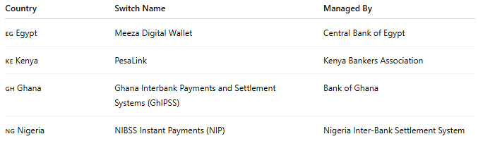

Country | Switch Name | Managed By
🇪🇬 Egypt | Meeza Digital Wallet | Central Bank of Egypt
🇰🇪 Kenya | PesaLink | Kenya Bankers Association
🇬🇭 Ghana | Ghana Interbank Payments and Settlement Systems (GhIPSS) | Bank of Ghana
🇳🇬 Nigeria | NIBSS Instant Payments (NIP) | Nigeria Inter-Bank Settlement System

✅ Benefits of Mobile Money Switches
# Source: AI Source: Provided by: [Data Path: Persons Table -> ID Column: 1, Name_En Column: Motasem Essam] -> From: [ChatGPT] on [1/21/2026]
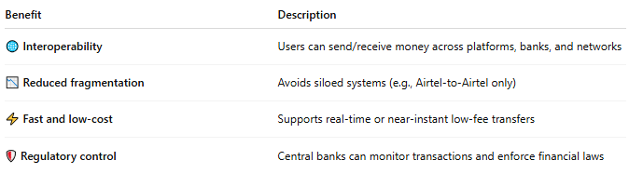

Benefit | Description
🌐 Interoperability | Users can send/receive money across platforms, banks, and networks
📉 Reduced fragmentation | Avoids siloed systems (e.g., Airtel-to-Airtel only)
⚡ Fast and low-cost | Supports real-time or near-instant low-fee transfers
🛡️ Regulatory control | Central banks can monitor transactions and enforce financial laws

📦 Use Cases
# Source: AI Source: Provided by: [Data Path: Persons Table -> ID Column: 1, Name_En Column: Motasem Essam] -> From: [ChatGPT] on [1/21/2026]
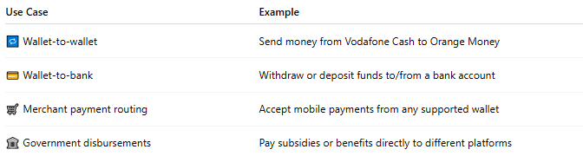

Use Case | Example
🔁 Wallet-to-wallet | Send money from Vodafone Cash to Orange Money
💳 Wallet-to-bank | Withdraw or deposit funds to/from a bank account
🛒 Merchant payment routing | Accept mobile payments from any supported wallet
🏛️ Government disbursements | Pay subsidies or benefits directly to different platforms

⚠️ Challenges
# Source: AI Source: Provided by: [Data Path: Persons Table -> ID Column: 1, Name_En Column: Motasem Essam] -> From: [ChatGPT] on [1/21/2026]
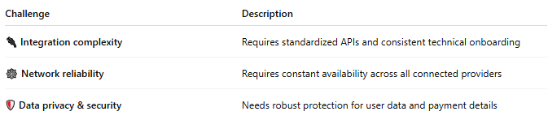

Challenge | Description
🔌 Integration complexity | Requires standardized APIs and consistent technical onboarding
🕸️ Network reliability | Requires constant availability across all connected providers
🛡️ Data privacy & security | Needs robust protection for user data and payment details

🧠 Summary
# Source: AI Source: Provided by: [Data Path: Persons Table -> ID Column: 1, Name_En Column: Motasem Essam] -> From: [ChatGPT] on [1/21/2026]
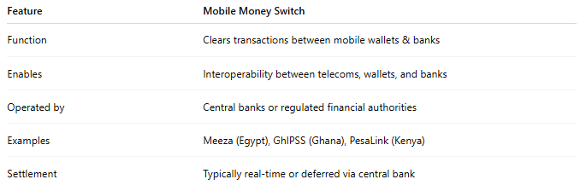

Feature | Mobile Money Switch
Function | Clears transactions between mobile wallets & banks
Enables | Interoperability between telecoms, wallets, and banks
Operated by | Central banks or regulated financial authorities
Examples | Meeza (Egypt), GhIPSS (Ghana), PesaLink (Kenya)
Settlement | Typically real-time or deferred via central bank

